## **Transformer Design**

In order to determine the turn ratio of the transformer, we can look at the push pull converter voltage equation.

$$V_{out}={2*V}_{in}*D*\frac{N_{2}}{N_{1}}$$

In the design requirements, we know that input voltage varies between the 24V and 48V. Also, push pull converter requires duty cycle which is smaller than the 0.5.

If we put a range for duty cycle such as 0.15 < D <0.3, we can find the necessary turn ratio

$$15=2*48*0.2*\frac{N_{2}}{N_{1}} =>\frac{N_{2}}{N_{1}}=1$$

Minimum number of turns can be determined as the flux density in the core cannot reach the saturation. So, minimum number of turns can be calculated as following formula.

$$\frac{V_{input-max}*D_{maxi}*\frac{1}{f_{s}}}{{2*B}_{sat}*A_{e}}=N_{1}$$

Then, we can use the effective area of the core. Our first core decision is the TDK Electronics B66335G0000X187 magnetic core. Its effective cross-sectional area is 354 mm2 .

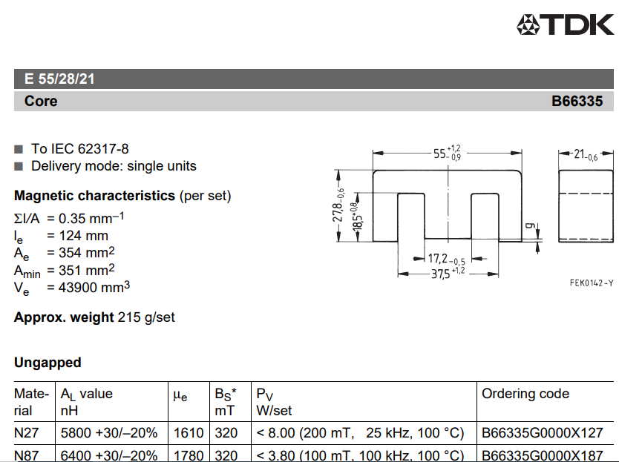

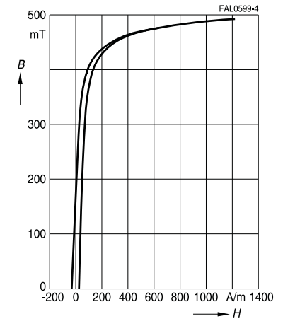

Maximum flux density varies depends on the material of the core. For a safety, we can select as maximum 0.2 T.

$$N_{1-min}=\frac{48*0.3*\frac{1}{100k}}{2*0.2*354x{10}^{-6}}≅1$$

In order to put a safety, number of turns can select as 4 turn primary and 4 turn secondary.

In the simulation, maximum current is 2.2 A for input, 3.3 A for the output. Also, our core has more window area. So, we decided to use directly a litz cable which has 3.14 mm^2 area which can carry nearly three or four times the expected currents. Then, when we calculate the fill factor, we obtained the following calculation

$$Fill Factor=\frac{\left(8+8\right)*3.14}{\left(10.15*18.5\right)*2}=\%10$$

## **Inductor Design**

In the Push Pull topology, we need an inductor. We assumed that inductor current ripple is around %10 of the maximum output current.

$$Δi_{L}=3*0.1=0.3 A$$

Then, we can write the inductor voltage equation as:

$$V=L*\frac{Δi}{Δt}L=V*\frac{Δt}{Δi}=\frac{\left(\left(V_{S}*\frac{N_{S}}{N_{P}}-V_{O}\right)*\left(\frac{D}{f_{s}}\right)\right)}{Δi}=\frac{\left(\left(48*1-15\right)*\left(\frac{0.3*2}{100e3*2}\right)\right)}{0.3}$$

$$=330 μH$$